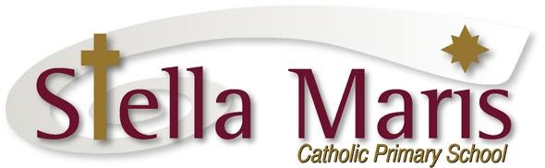

Monday 10th May

Dear Parents,

On Wednesday 2nd June, the Mokehu team will be travelling by bus to the Auckland Museum as part of our ‘Change’ topic that we are studying in Term 2. We will be having a learning session with the Museum Teachers about Volcanoes and will also have the opportunity to explore the Museum.

We will be leaving school at 9am and returning by 2pm. It is important that your child is at school before the 8.45am bell on this day as we cannot delay the buses.

The children will wear their school uniform and will take their drink bottles and lunches.

We require parent help for the trip. Please complete the form below and return to your class teacher.

The cost of the trip is $12 which covers the buses. There is no fee for the parent helpers.
Please pay this online to 12-3046-0362238-000 with your child’s last name and museum as the reference. Or else you can pay via EFTPOS at the front office.

Thank you,
Mokehu Teachers

--------------------------------------------------------------------------------------
Mokehu Auckland Museum Trip

I give permission for _________________ from St _________ to attend the Mokehu Auckland Museum trip on Wednesday 2nd June.

I have paid $_______ online/EFTPOS date ______

I am able to parent help for the Auckland Museum trip
Name __________________
Phone Number __________________

