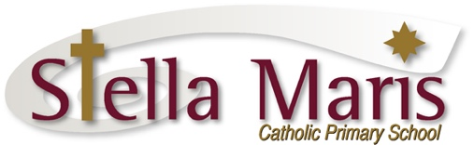

Dear Parents and Caregivers

Thank you for your interest in Stella Maris Catholic Primary School. I welcome your enquiry and consideration of our school community as a place for your child’s education.

At Stella Maris our teaching and learning programmes engage students in learning and ensure high levels of achievement in a safe and secure environment. We have a dedicated staff who ensure the individual learning needs, interests, strengths and aspirations of the students and their whānau are met.

As a Catholic school our Catholic Special Character underpins all that we do and who we are as a school community. We follow the example of Mary, Star of the Sea who is our navigator on our shared faith journey with Jesus and there is an expectation that all actions and behaviours will be guided by the Marian Values.

The Stella Maris community is based on family, whānau. The family consists of students, staff, whānau, and the Hibiscus Coast Parish who join together to form a community that is wholeheartedly committed to the education of our young people.

We encourage, and indeed expect, that our students will become life long learners, each developing the Spirit of Stella Maris to take them on to further education, into the workplace and adult life. The Key Competencies in the New Zealand Curriculum are at the base of all learning and ensure our students are self managing, relate well to others, and participate and contribute actively in their learning journey.

Central to the mission of Stella Maris is the promotion of excellence. Our commitment to our whānau is to provide an inclusive and safe environment that challenges, supports and empowers each individual to be the best they can, thereby preparing them for the next steps on their learning journey.

I look forward to receiving your application and welcoming your family into the Stella Maris Community.

Ma te Atua koe e manaaki
May God Bless you

Catherine Cyprian
Principal

“Tiaho mo te Atua - Shine for God”

