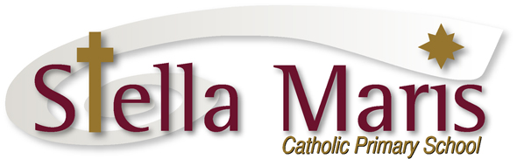

4 December 2019

End of Year Reminders for Year 6 Families

Dear Parents of the Year 6 students

We are looking forward to celebrating our year with you all on Thursday 19 December at the Thanksgiving Liturgy (11am) and then the Year 6 Graduation Dinner in the evening (5:30pm).

Below is some information related to parent involvement at the Thanksgiving Liturgy:

Thanksgiving Liturgy – Thursday 19 December 11am:
At the end of the Thanksgiving Liturgy we will be “handing back” the year 6 students to you, their parents, to send them on the next step of their learning journey.

Towards the end of the liturgy we will ask that all parents of the year 6 students move quickly and quietly out into the foyer of the church. I will meet you in the foyer to help direct you.

You will need to organise yourselves into class groups. Each class group of year 6 students will follow behind their class teacher down the centre aisle to be handed back to their parents. This will be done in the following order:
- St Augustine
- St Dominic
- St Joseph

As each group is handed back to you we ask that you move with your child to the space along the back of the church, staying inside the main body of the church, so that the next group of parents can move forward to receive their children.

Please note the children will travel back to school on the buses.

Year 6 Graduation Dinner Reminders:
A reminder to please RSVP and make payment to the office by this Friday, 6 December for the Year 6 Graduation Dinner.

If you require another copy of the invitation for this event it is available on the website and the App.

We look forward to sharing this day with you all.

Kind regards
Catherine Cyprian
Associate Principal

