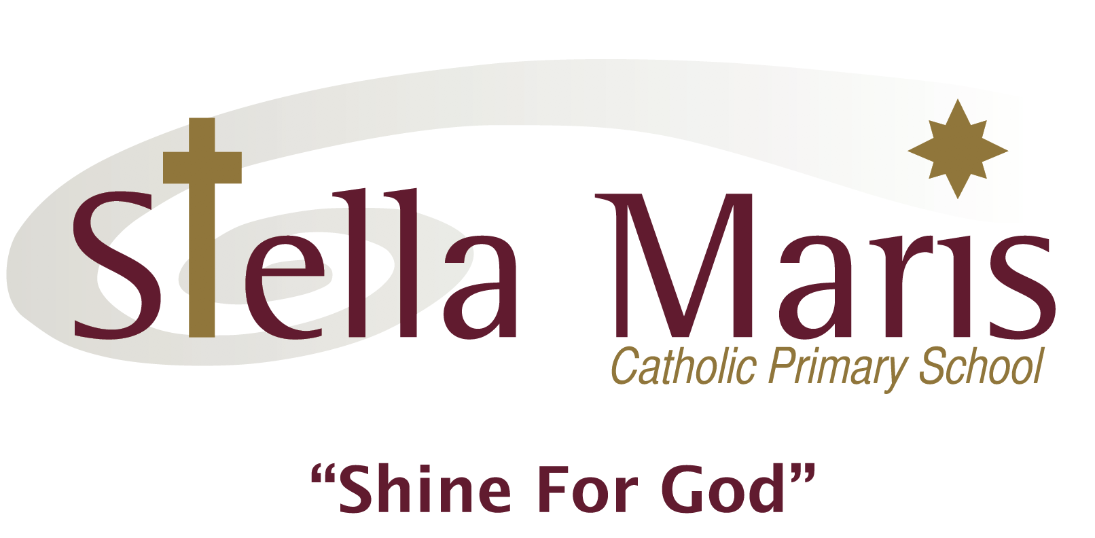
Wednesday 23 October

Dear Parents and Caregivers,

Stella Maris Choir are regularly invited to sing at the St John’s HBC Parish Christmas Lunch in Orewa. This year, I am taking a Year 3 and 4 choir.
We will need to transport the choir down to St John’s in Orewa (180 Centreway Road) leaving the school at approximately 11:20am and returning around 12:45pm. We will sing for around 20-30 minutes.

If you are able to assist with transport, can you please fill in the slip below.

All choir members will need the permission slip to be returned before they can go to this performance.

There is no cost for this event.

If you have any questions, please feel free to email me at olwyn@stellamaris.school.nz , or alternatively, pop in and see me before school in St John class in the middle atrium.

Thank you for your support in this.

Kind regards
Olwyn Hobman

My child : _____________________________ has permission to attend the Y3/4 choir on Monday 18 November 2019. I understand they will be travelling to and from St John’s church with parents in cars.

Signed: ___________________________. Name: ______________________

Email: ____________________________ Phone: _______________________

I am able to assist with transport to and from St John’s Church on Monday 18 November.

I am able to take ____________ children.

Signed: ___________________________. Name: ______________________

Email: ____________________________ Phone: _______________________

