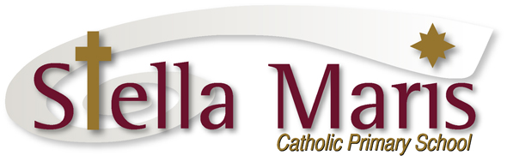

25 March 2019

Dear Parents
The Great Kiwi Science, English and Mathematics Competitions

This year instead of the NSW ICAS tests we are offering the Great Kiwi Science, English and Mathematics Competitions to year 5 and 6 students. These tests are optional.

These Kiwi competitions/tests are based upon the New Zealand Curriculum and have been developed by Kiwi teachers working with the University of Canterbury. Like the ICAS tests students, parents and teachers will receive an independent comprehensive record of the student’s performance in the test. These tests are completed online and are supervised by the school. They will be carried out mid-June. Each test costs $9. Your child has the option of completing one, two or all three of the tests.

At this stage I am seeking expression of interest so that I can complete the initial registration. Please fill in the slip below and return it to me through the school office by this Friday, 29 March.

DO NOT send any money at this time, this is just an expression of interest. The formal registration forms will be sent home with the students at the beginning of next term.

NB: We will not be offering the ICAS tests this year.

If you have any questions please contact me through the school office or email.

Regards
Catherine Cyprian
Associate Principal
catherine@stellamaris.school.nz

Please return this slip to Miss Cyprian through the school office by Friday 29 March

The Great Kiwi Science, English and Mathematics Competitions

My child _______________________________________ in St ______________________

is interested in sitting the following Kiwi tests:

Science English Mathematics

SEND NO MONEY AT THIS TIME

Parent’s name: ____________________________ Signed: __________________________

