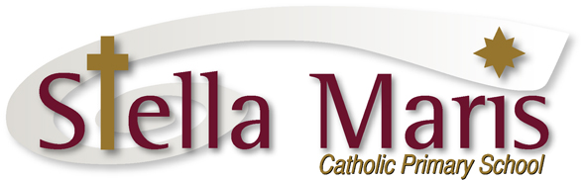

23 July 2018

Dear Parents

Changes to the Bayes Buses – New Buses Joining the Fleet

Over the next week or so some of the Bayes buses on the Hibiscus Coast school bus services will be changing to new buses. These buses will look different as they will have the Auckland Transport branding.

The bus routes will be the same – picking up and dropping off at the same stops. The drivers will also be the same, though they will be wearing Auckland Transport uniform.

From tomorrow, Tuesday 24 July, these changes will apply to the Stella Maris bus route for Whangaparaoa/Gulf Harbour, Lou will continue to be our driver. Students will need to look out for the route information on the front destination sign on the bus.

These changes may also affect other BAYES buses that the children use when transferring at Silverdale/Kingsway schools. Please be aware of these changes and look out for the buses, check the route information on the front of the bus.

Regards
Catherine Cyprian
Associate Principal

