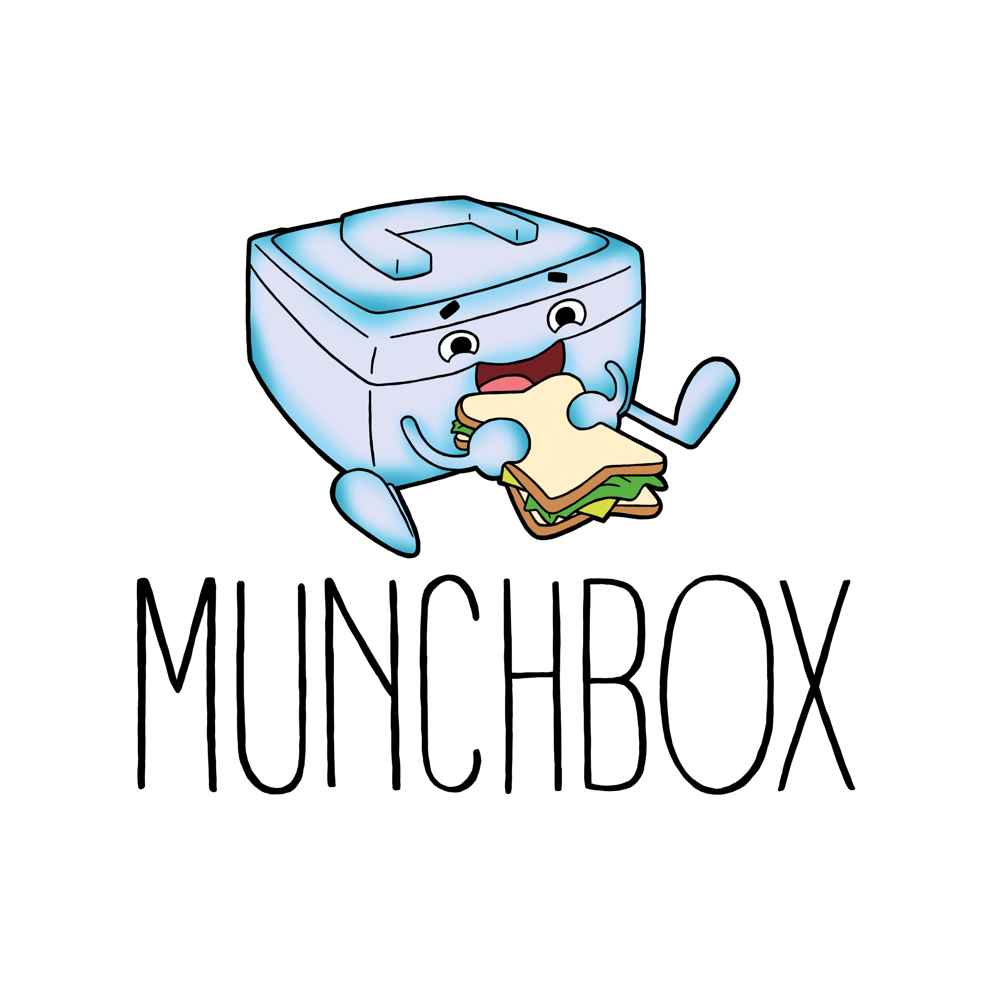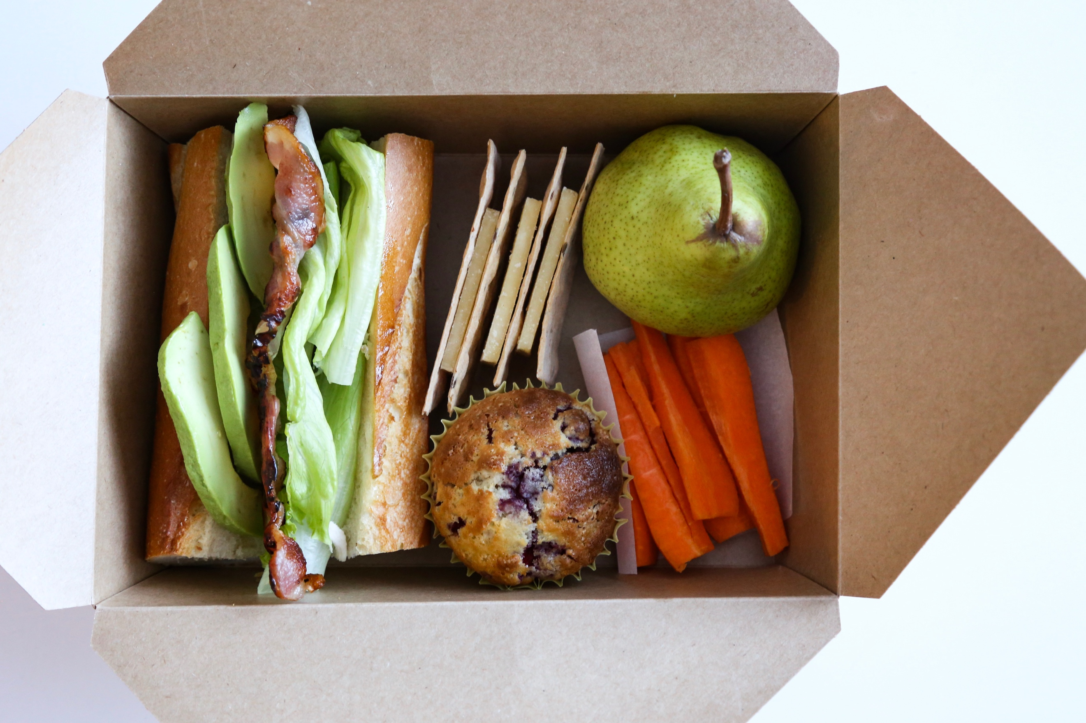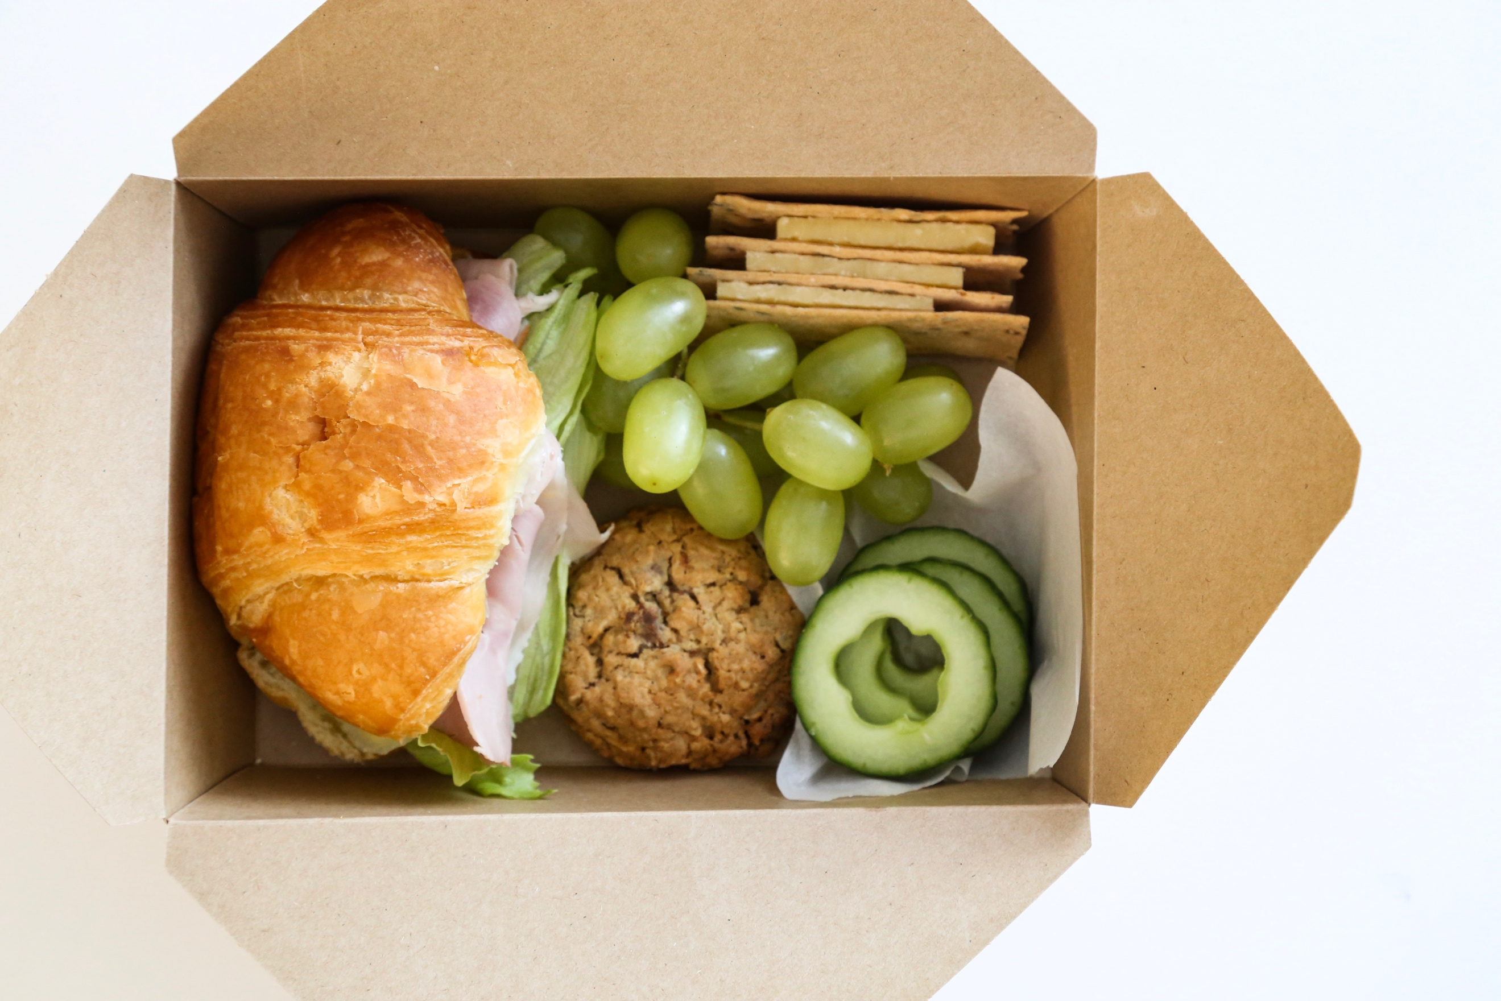

Munchbox is a new healthy online lunch delivery service offered to children at Stella Maris School from 28th May. Munchbox is designed to make your life easier; simply order online and have a healthy and tasty Munchbox delivered to your child, Monday-Thursday. Our wholesome ‘Munchboxes’ not only care for the health of your children but also for the environment, folding down easily to be either composted or recycled at home. Munchboxes cost $8 for a single day or $30 for four days (Monday through Thursday). Please check out www.munchbox.nz for more information and how to place orders. Any queries please contact Munchbox directly.
hello@munchbox.nz
www.munchbox.nz
https://www.facebook.com/www.munchbox.nz/

