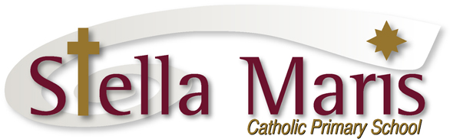

2 March 2018

Dear Parents

Stations of the Cross

Each week throughout Lent Stations of the Cross will be held at both of the churches within the Hibiscus Coast Parish. Friday evenings, 7:30pm at St Johns, Orewa, and Sunday afternoons, 4pm at St Francis, Stanmore Bay.

This year families and groups within the parish community lead the Stations of the Cross. We have offered for a group from Stella Maris to lead the Stations of the Cross on Friday 16th March at St Johns, Orewa at 7:30pm – it takes about half an hour.

We are looking for Yr 5-6 students who would be interested in leading the Stations on this evening. Mrs Bodle and I will prepare the group prior to the evening, and be there to support the group on the evening.

If your child is able to take part in this please return the slip below to Mrs Bodle through the school office by next Tuesday 6 March.

Everyone is very welcome to attend either the Stations that Stella Maris leads on 16th March or any of the other Stations of the Cross.

Kind regards

Catherine Cyprian
Associate Principal

Please return this slip to Mrs Bodle through the school office by Tuesday 6th March

Stations of the Cross
St Johns Orewa, 7:30pm 16th March

My child ___________________________________ in St _________________________ is able to help lead the Stations of the Cross on Friday 16th March at 7:30pm at St Johns Orewa.

Parent’s Name: _______________________________ Signed: ________________________

Phone: __________________________

Email:

