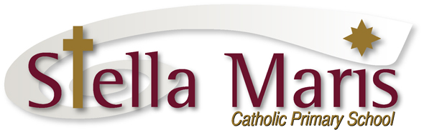

12 April 2017

Dear Parents

Ritchies Bus Route 1509

The proposed changes for Ritchies bus route 1509 will not be taking place at the beginning of term 2. They have been postponed while the bus company and Auckland Transport work together to best meet the needs of all students, including the Stella Maris students who have been allowed to use this bus.

We will inform you of any changes once they have been finalised and the new timeline has been put in place.

Regards
Catherine Cyprian
Associate Principal

